Activity No. 06
Aim: Create LAN network , Connecting Computer in Networking or share the resources.
Theory:

How to Set Up a LAN Network :
LAN (Local Area Network) is a data communication network that locally connects network devices such as workstations, servers, routers, etc. to share the resources within a small area such as a building or campus. Physical or wireless connections are set up between workstations to share the resources. Ethernet and Wi-fi are the most important technologies of LAN. Personal networks at home, school, office, etc. are examples of LAN. These are generally privately-owned networks.
Requirements to set up LAN Network:
- Workstation/Personal devices: laptop, computer, mobile phones, etc.
- Network devices: router, switch, modem (if not already present in the router)
- Sharing resources: printers, disk drives, etc.
- Cables: Ethernet cables, wires for connecting other devices (in case of wired LAN)
- Internet connection: Wi-Fi (in case of wireless LAN)

Instructions to set up LAN Network:
Following steps should be followed to set up a LAN network:
- Identify services: Identify the network services such as printers, disk drives, data, etc. that will be shared among workstations.
- Identify devices: Identify devices such as computers, mobile phones, laptops, etc. with a unique address that will be connected to the network.
- Plan connections: Design the network by laying out cable wires between network devices or by making wireless connections. Wired LAN is set up using Ethernet cables while wireless LAN is set up using Wi-Fi that connects network devices without making any physical connection. A wired LAN network is more secure than a wireless LAN network but it is difficult to relocate.
- Select networking device: Select switch or router with enough ports to connect all workstations within the network. The choice of networking device is based on the requirements of the network.
- Configure ports: Configure WAN ports according to the information provided by ISP (Internet Service Provider). Also, configure LAN ports of cable routers such that there are enough addresses available for all the workstations within the network. A cable router acts as DHCP (Dynamic Host Configuration Server) server that automatically allocates addresses to all the devices connected to the network.
- Make connections: Connect all the devices using wires to configure a LAN network. Standard Ethernet cables are used to connect workstations and servers while Ethernet crossover cable is used to connect the switch to cable routers by connecting the standard port of the switch with router’s LAN port. For wireless LAN, connect all the devices to Wi-Fi with SSID (Service Set Identifier) provided by the router or switch to configure the LAN network.
- Test the network: Test each of the workstation connected to the network and ensure every workstation have access to network services.

Tips for LAN Set-Up:
- Make a comprehensive plan about connections before making actual connections to avoid confusion.
- Carefully identify the requirements and size of the network and plan accordingly.
- Smartly choose the networking device which provides more flexibility to the network.
- Ensure the cable length is not more than 100 meters.
- Avoid laying cables in air ducts unless fire rated.
- Perform detailed testing after network set up to analyze the actual performance of the network.
Applications of LAN:
- Resource sharing: LAN network allows workstations connected to the network to share resources such as printers, scanners, CD drives, etc. which reduces the cost of the set up of the network.
- Software sharing: LAN network allows to share a single copy of licensed software among workstations connected to the network instead of purchasing separate software for each computer.
- Internet sharing: LAN network facilitates sharing of internet connection among all the devices connected to the network.
- Data sharing: LAN network allows different workstations to share the data and files with each other. It also allows access to data stored on the central server.
- Communication: Devices connected to a LAN network can communicate with each other.
Advantages of LAN:
- It is an easy and cheap way of communication within a small geographical location.
- It is easy to expand the network by connecting workstations to a central server.
- It is easy to manage the resources and data from the central server.
- It is more secure since data is stored on a central server which denies illegal access to data.
- It has high data transmission rates.
Disadvantages of LAN:
- It has a high initial setup cost.
- It violates the privacy of network users as administrators have access to all their data and files.
- It can face security issues if the central server is not properly secured.
- It needs regular maintenance to deal with issues such as software installations, hardware failures, cable disturbances, etc.
- It restricts the size of the network.

Setting Up a Basic LAN :

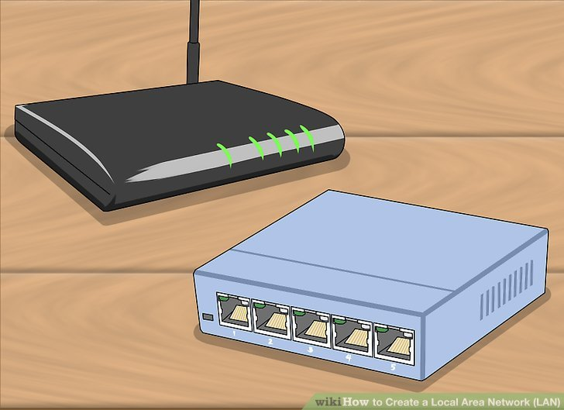
1. Gather your network hardware. To create a LAN, you'll need a router or switch, which will act as the hub of your network. These devices route information to the correct computers.^{[2]}
- A router will automatically handle assigning IP addresses to each device on the network, and is necessary if you intend to share your internet connection with all the connected devices. It is highly recommended that you build your network with a router, even if you're not sharing an internet connection.
- A network switch is like a simpler version of a router. It will allow connected devices to talk to each other, but will not automatically assign IP addresses and will not share an internet connection. Switches are best used to expand the number of LAN ports available on the network, as they can be connected to the router.

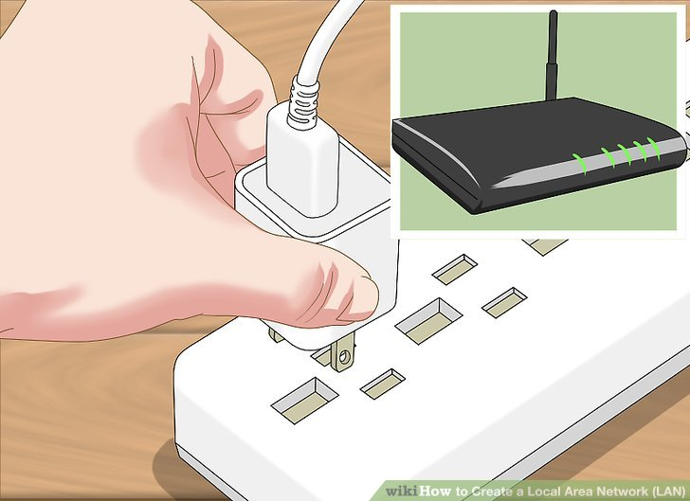
2. Set up your router. You don't need to do much to set up a router for a basic LAN. Just plug it into a power source, preferably close to your modem if you plan on sharing the internet connection through it.
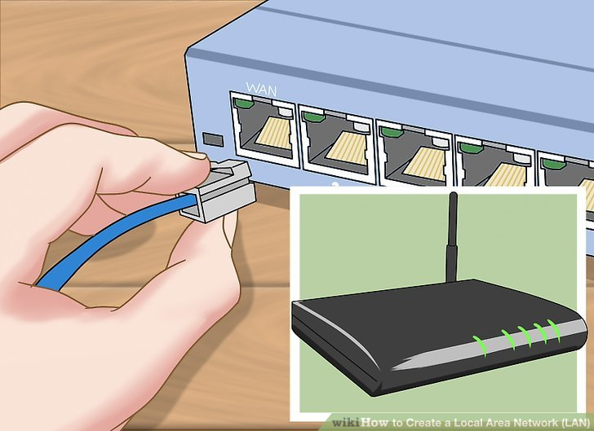
3. Connect your modem to your router (if necessary). If you're sharing the internet connection from your modem, connect the modem to the WAN/INTERNET port on the router. This is usually a different color from the other ports.

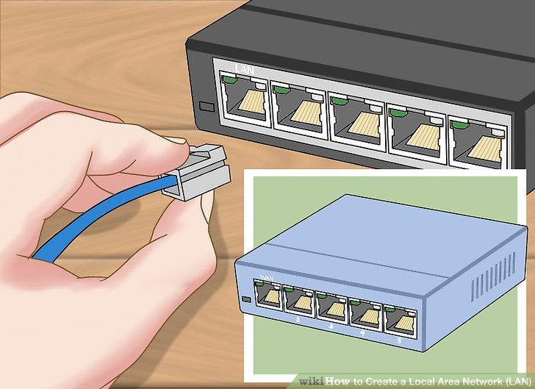

4. Connect your switch to your router (if necessary). If you're using a switch to expand the number of ports available on the router, plug an Ethernet cable into any LAN port on the router and any LAN port on the switch. This will expand the network to the rest of the LAN ports on the switch.
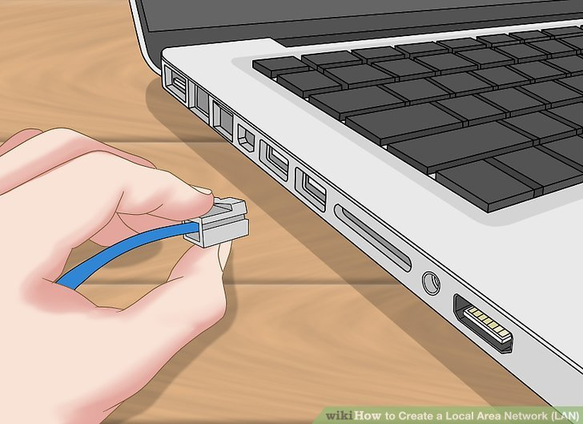

5. Connect your computers to open LAN ports. Use Ethernet cables to connect each computer to an open LAN port on your router or switch.^{[3]} It doesn't matter what order the ports are connected in.
- Ethernet cables cannot reliably transfer data at lengths larger than 100m (328 ft).
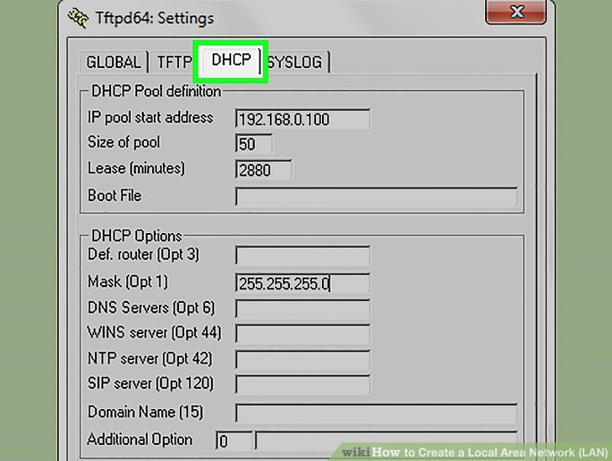
6. Setup one PC as a DHCP server if you're just using a switch. If you're only using a switch as your network hub, setting up one computer as a DHCP (Dynamic Host Configuration Protocol) server will allow all of the connected computers to easily obtain IP addresses.^{[4]}
- You can quickly create a DHCP server on one of your computers by installing a third-party utility.
- The rest of the computers on the network will obtain IP addresses automatically once the server is running, as long as they are set to do so.
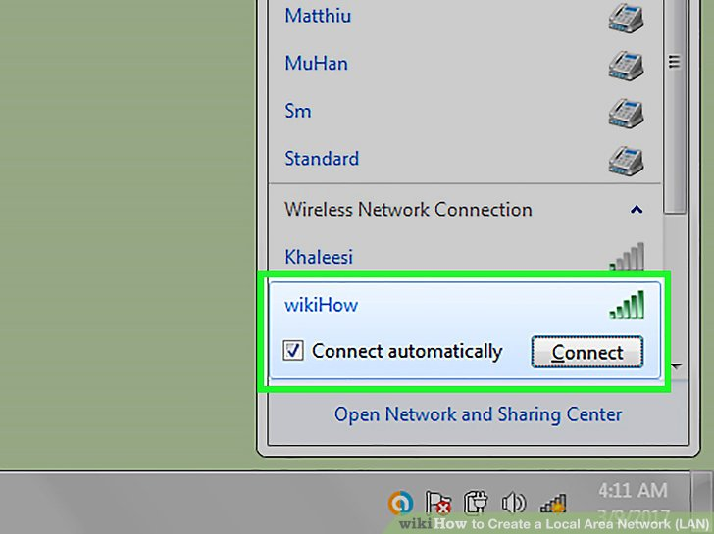
7. Verify the network connection on each computer. After each computer obtains an IP address, they'll be able to talk to each other on the network. If you're using a router to share your internet connection, each computer will be able to access the internet.
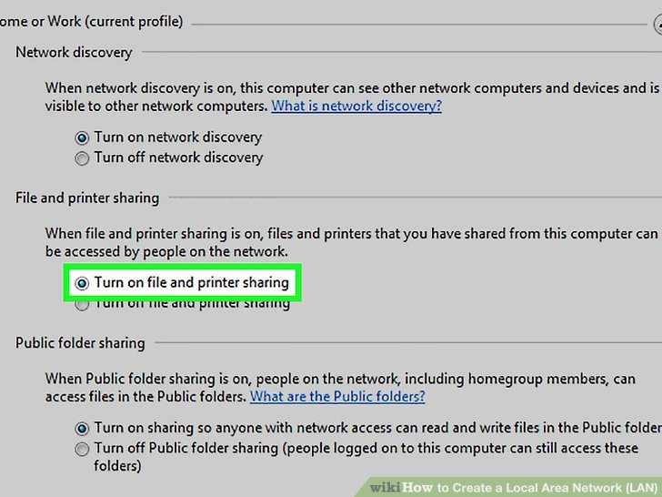
8. Set up file and printer sharing. Once your network is up, you won't see anything on other computers unless that computer has shared files. You can designate files, folders, drives, printers, and other devices as shared so that anyone on the network, or just specific users, can access them.^{[5]}

